**STAT 40001/ STAT 59800 Statistical Computing Fall 2020**

**Lab-4**

**1)** Go to <http://www.amstat.org/publications/jse/jse_data_archive.htm>

a) Import the ***babyboom.dat.txt*** data which has Time of Birth, Sex, and Birth Weight of Babies and number of minutes after midnight.

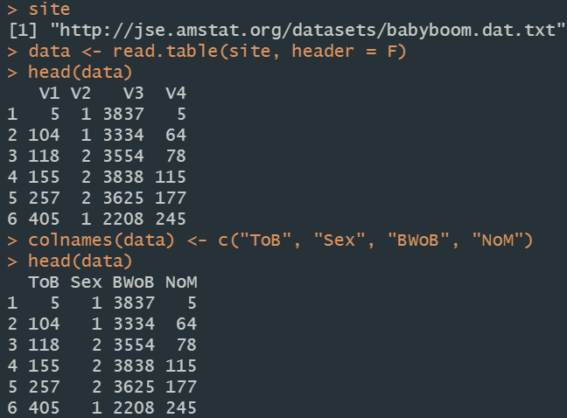

b) How many observations are recorded?



c) Print first 5 observations

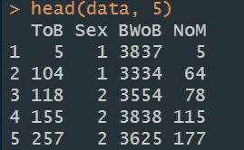

d) Print last 5 observations

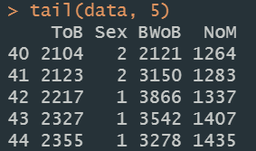

**2)** Murder rates for some Southern US cities is provided in the data set named  *south* in the *UsingR* package. How many observations are included in the dataset south?





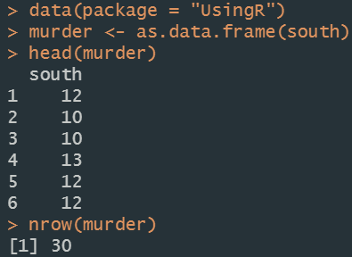

**3)** For 1997-2002, from police-reported car crashes in which there is a harmful event (people or property), and from which at least one vehicle was towed (Data are restricted to front-seat occupants, include only a subset of the variables recorded, and are restricted in other ways also), are provided as Item “nassCDS” under Rich source of data in Useful link.

a) Import the data in R using appropriate R code



b) Print the first 5 observations.

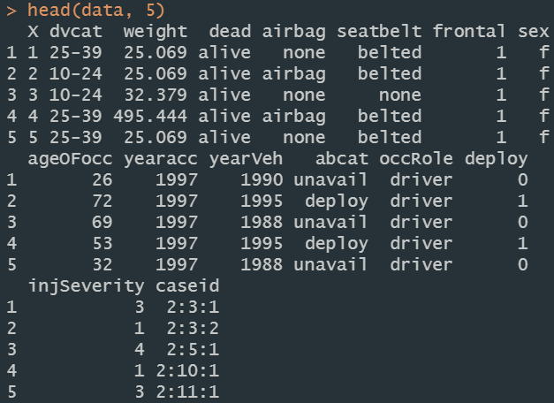

**4)** Consider a data set where the columns are separated by $

Col1$Col2$Col3

1$2$3

4$5$6

7$8$9

a$b$c

Save the data in a local drive and import it in R by removing $ sign.

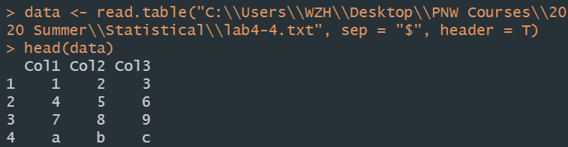

**5)** URL below contains data related to the number of publications produced by Ph.D. biochemists.

<http://www.stata-press.com/data/lf2/couart2.dta>

1. Import the data in R. (Note that this is Stata data)



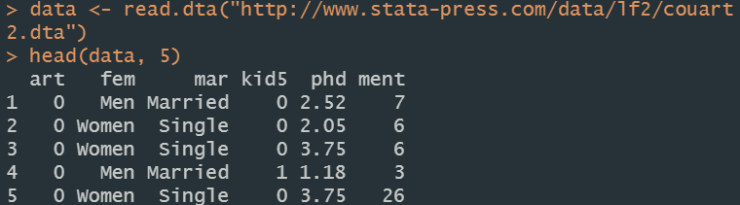

1. List the variables included in the data



1. State the dimension of the data



6) The link below provides the data related to what kind of feed can help grow healthier chickens. It includes the weights of chickens based on type of food.

<https://raw.githubusercontent.com/vincentarelbundock/Rdatasets/master/csv/datasets/chickwts.csv>

1. Import the data in R

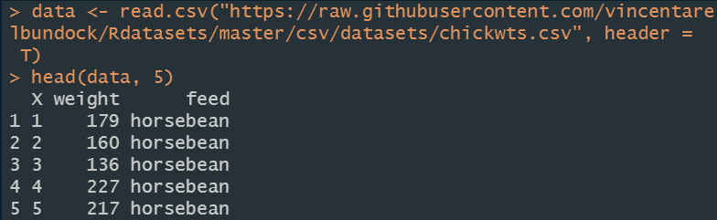

1. Determine the dimension of the data



1. Is there a missing value?

